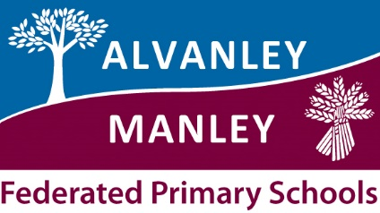
Alvanley Primary School
Alvanley
Frodsham
Cheshire
WA6 9DD
01244 981211

Tel: 01244 981211

Manley Village School
Manley
Frodsham
Cheshire
WA6 9DU
01244 981201

Tel: 01244 981211

Together we nurture, inspire and achieve

Headteacher: Mr V Thapar
E-mail: head@alvanley.cheshire.sch.uk
head@manley.cheshire.sch.uk
_____________________________________________________________________________________________
Reception Children and Children in Year 1 + 2 taking part in the Day Trip to Conwy

Dear Parents,

As you may be aware, we are taking our Year 1 and 2 children on a Residential Visit for an overnight stay. This year the residential visit will be to Conwy Castle and we will be staying overnight in the Conwy Youth Hostel on Wednesday 4th March. Each year we invite our Reception children to participate in the first day of this visit before returning back to school.

For those children in Year 1 and 2 who have chosen not to attend the residential and stay overnight; we thought this would be a wonderful opportunity for them to come along and experience Conwy along with the rest of the class. They will come back to school with the Reception children on the same day.

The children will travel to Conwy by coach at 9:15am on Wednesday 4th March where they will have the opportunity to explore the castle and its geographical features. They will then visit the Youth Hostel where the other children will be staying. This will give them time to familiarise themselves with this type of environment in anticipation of their own future residential visits as they progress through school.

We will be leaving school after morning registration and it is anticipated that they will return to school at approximately 5.30pm, traffic dependent.

The children will require:
- a snack and drink in disposable packaging for morning break
- outdoor clothing, including a waterproof coat with hood and strong outdoor shoes, such as trainers.
- a small rucksack to enable them to carry their own belongings throughout the day.
The cost of this visit is £17.00 which includes transport, additional snacks and the cost of activities. A packed lunch will be provided by school as the children are entitled to ‘universal free school meals’. However, the children will still require tea when they arrive home.

If you wish your child to take part in this visit then we would ask you to complete the consent form and make full payment online by Friday 7th February.

Yours sincerely,

Miss Deacon

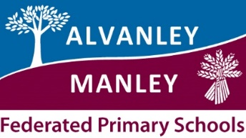

Conwy Day Trip KS1 – 4th March 2020
Name of child /children: _________________________________________________
Year Group _______________________________
I give permission for my child/children to attend the day trip to Conwy on 4th March 2020.
I have paid £17.00 per child online and understand that this is non-refundable.
Signed _________________________________________________ Date ___________________________

We plan educational visits very carefully however the cost of these visits, especially residential visits, is prohibitive and we cannot provide the amount required from our school funds. We believe the benefits of this curriculum enrichment are outstanding thus we ask parents for assistance. Without these contributions the educational visit will be cancelled. If you need to discuss any payment issues please speak to Mrs Lishman in the office.

