Quick Guide to the Giving Machine.
https://www.thegivingmachine.co.uk
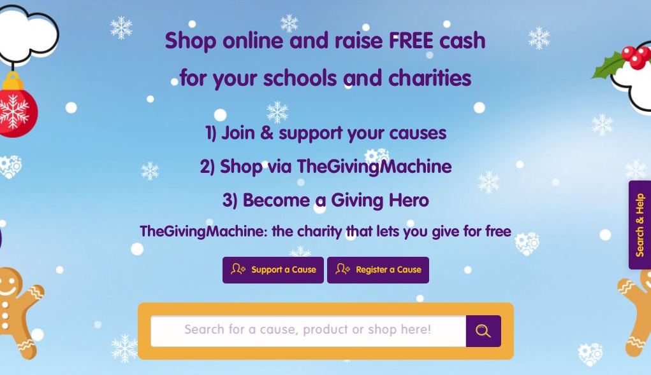
- Enter Alvanley Primary School into search box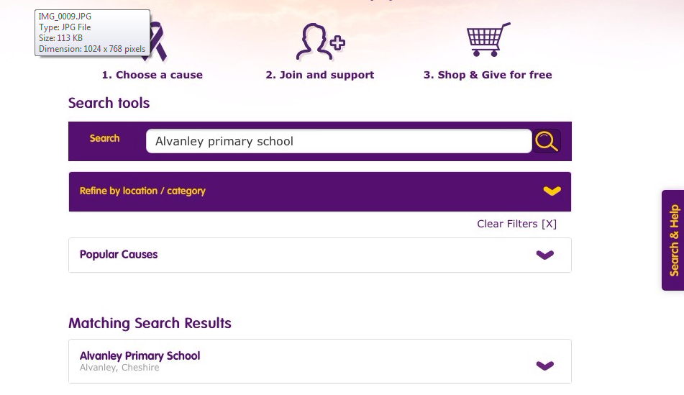
- The results come up and then the join and support button is shown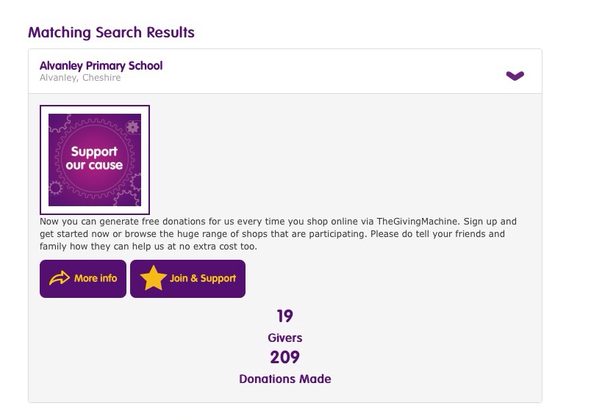
- You then get a thanks – you can have more than 1 cause. 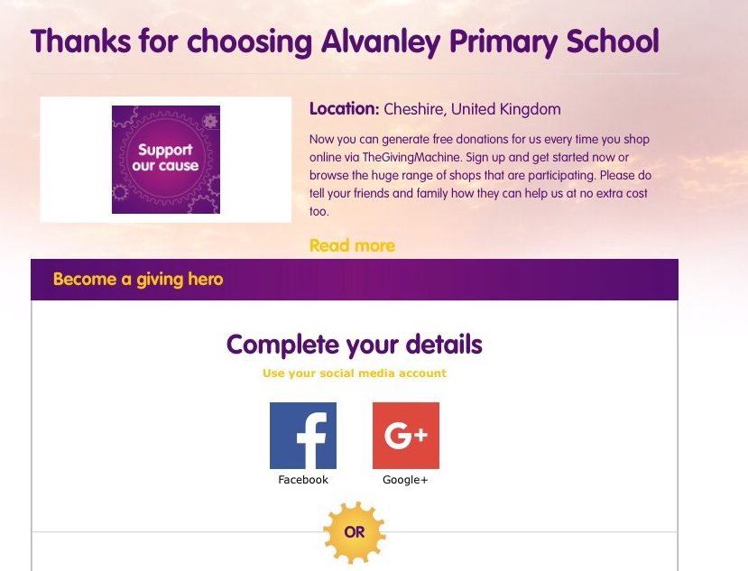
- Yon can then complete your detail via social media or email sign up (don’t forget to gift aid if eligible)
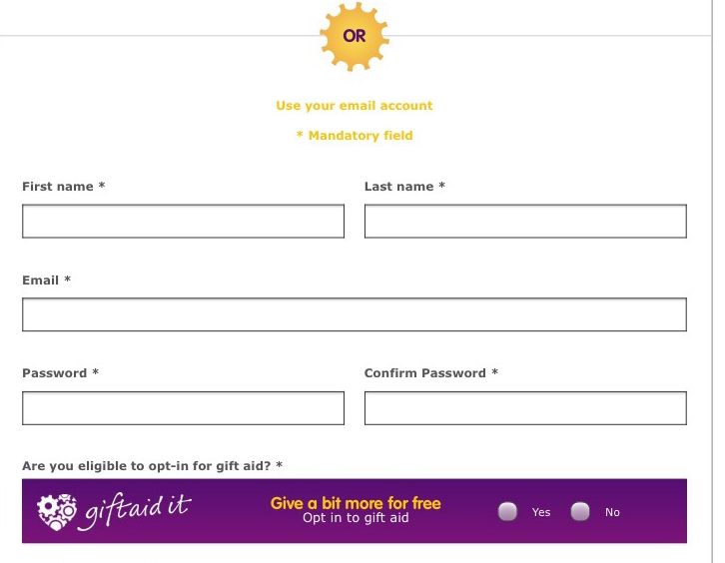
- Once you have filled in your details – hit Join! 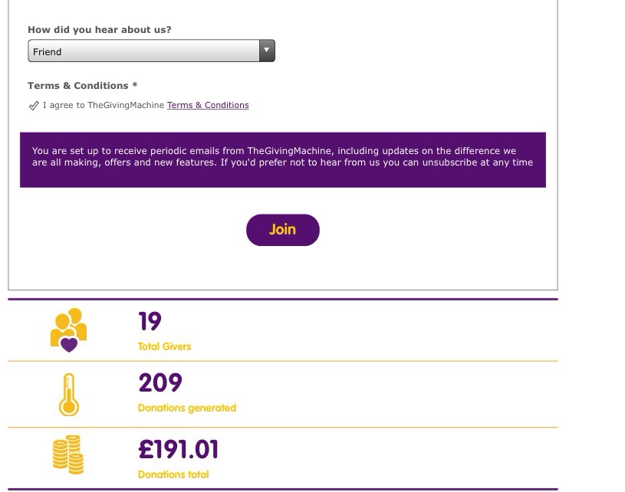
- You then get a confirmation email and it lets you know about the App to dowload. 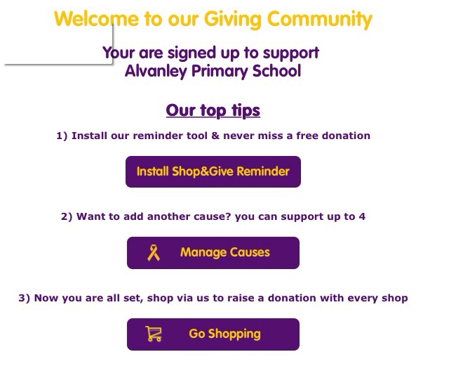
- Once you have downloaded the App – you can login and it will stay logged in
- You can then type in the shop you want, once selected just hit the trolley icon and it takes you to the shop
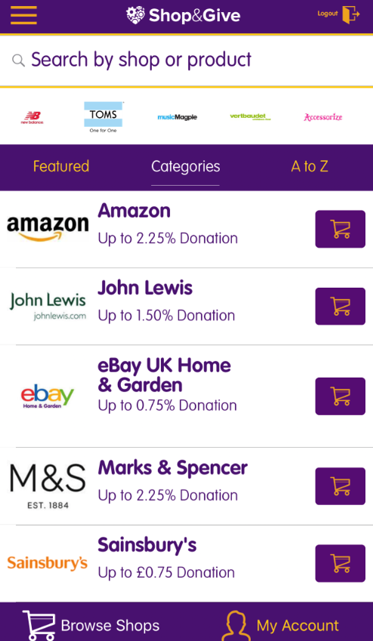
- It can take several days for the donation to show up – but it does and then shows how much you have raised.
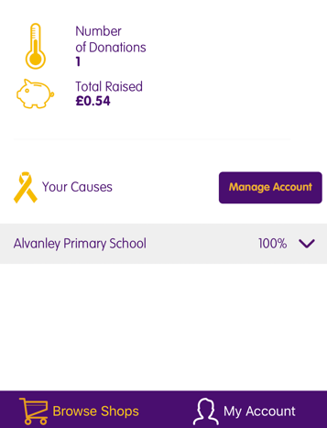

- I found it easier to set up on desktop/tablet – rather than phone. You can add shops, so that you don’t have to keep searching for them. Then once you are set up – shopping on your phone is easy.
- There are help pages for any questions.

Enjoy raising funds!

