**Friends of Alvanley Primary School**

**Christmas Fair – Non-Uniform Days**

Thank you so much for your generous donations of bottles before half term for the Christmas Fair.

We have 2 further non-uniform days over the next couple of weeks to collect other donations to make the fair a success – please support us if you can.

For both dates please make sure your child dresses appropriately for school activities and especially that they have suitable footwear.

**“Chocoholics” – Wednesday 15th November**

**NOTE CHANGE OF DATE DUE TO CHILDREN IN NEED!!**

We are inviting the children to come into school in their choice of clothes for the day and make a donation of chocolate or sweets for our very popular chocolate tombola. Please make sure the sell by date is at least the end of December!

**“Christmas Colours” - Friday 24th November**

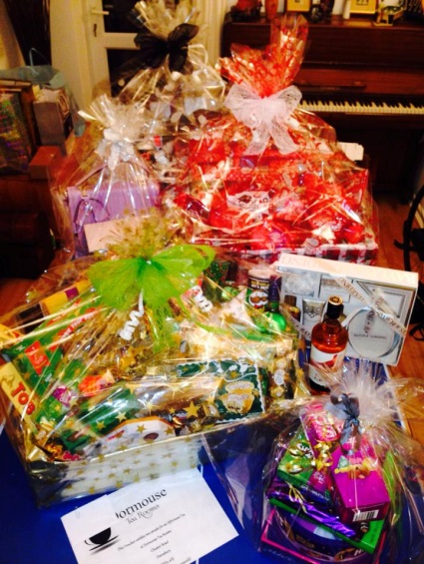

Our Christmas raffles have historically been superb fundraisers, with last year raffle raising nearly £500 for the school. For this years Christmas Raffle we again hope to be able to make up three gorgeous hampers as prizes. Toednesday help with this we ask each child to bring in an item for their class hamper. Each class hamper has a colour theme:

* Class 1 – Red and White
* Class 2 – Green and Gold
* Class 3 – Black and Silver

To encourage everyone to take part, to make it a bit more fun and to start getting us all into the Christmas spirit we are inviting children not only to bring in a colour themed item for their class hamper, but also to dress in their class hamper colour! There will be a small prize for the best dresser from each class! ***Hampers from 2016***

Please make sure that any food items donated have a use by / best before date of at least end Dec.

As well as the hampers we hope to have many other super raffle prizes (if anyone is able to donate any other prize big or small that would be great, please either see me, Lisa Forbes, Louise Gray or Lisa Green or drop into the school office). The raffle prizes will be on display at the Christmas fair on Monday 4th December but, to allow a bit more ticket selling time, will be drawn at the School Nativity in the last week of term. Tickets will be sent home soon and I would be grateful if you could sell these to family and friends.

Thanks for your support, your donations are really important to us and help the fair run smoothly.

Karen Chalmers, Friends of Alvanley PTA.

07759 128272.