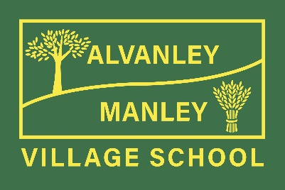
School Uniform Policy
At Alvanley & Manley Village School we recognise that school uniform plays a valuable role in contributing to the ethos of the school.
Having an identifiable uniform enables all children to feel that they belong to our school family and that they are proud to attend our schools.
It helps all children to feel welcome at the school, encouraging both a positive identity and good behaviour.
Our uniform reflects the high standards we strive for and above all, we believe that school uniform supports effective teaching and learning.
We expect children to dress smartly and attend school in the correct uniform. The expectation is that children must wear items with our school logo on or the same colour / design.

Uniform
School uniform is
A bottle green sweatshirt or cardigan, which can be embroidered with the school logo.
A pale white polo shirt.
Grey/ black skirts, trousers (not jeans) or shorts.
From the start of the summer term to the end of the first half of the autumn term, yellow or green gingham or similar summer dresses can be worn.
Sensible and appropriate black shoes (not trainers)

PE kits:
Bottle green and white PE kits, (if possible) printed with the school logo
Reception children can wear black shorts and an embroidered white cotton T-shirt if the standard PE kits are too large.
Please also provide your child with a pair of plimsolls / trainers (elastic sided for Infant children) or similar.
Uniform suppliers are:
Touchline
Orders can be placed online, telephone or email with the order form.
If parents choose the ‘free delivery to school’ option this may take up to 4 weeks.
If parents choose carriage to their home address this will be £3.95 for orders under £50 and free of charge for any orders over £50.
http://www.touchline-embroidery.net/alvanley-primary/
Other Sources
Generic items can be purchased from supermarkets / other clothes retailers.
The school holds a half-termly second-hand uniform day each half term, where uniform can be purchased at a heavily discounted rate.

General Appearance
All long hair must be tied back and hair accessories must be discreet.
Hairstyles should be appropriate for school at all times. Please note that we do not allow extreme hair styles such as dyed hair or hair cut with lines or patterns.
No jewellery, except small stud earrings, which must be removed for PE.
A small watch can be worn but please consider its value in the event of damage or if it gets lost.
No make-up or nail varnish.

