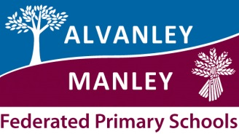
Alvanley Primary School 100 PTA Club
The schools 100 club is a really simple way for everyone to raise money for the school with the added benefit that you have the chance to win some money each month!
The idea is you buy a number – it costs just £12.00 for the whole year.
A monthly draw will take place. 50% of the money collected is used for the monthly prize and 50% goes to the school.
If we sell 60 of the 100 tickets – you have the chance to win each month £30.00, if we sell all of them the monthly prize money is £50.00!
You can buy more than one number. Friends and other family can also buy them.
In previous years we have raised over £300.00 for the school, this money has been used towards various activities and equipment for the children in the school.
If you would like to join the 100 club please complete your details and pass to the school/ Lynn Humphrey or any member of the PTA.
Name
Preferred Number (s)
Contact number or email
Childs name
Payment can be made using cash, Cheque (made payable to Friends of Alvanley Primary School) or Bank transfer sc 401714 acc 72295717 – if sending a bank transfer please use your name as reference and email Lynn Humphrey (lynnhumphrey15@gmail.com) to confirm payment made this way.

