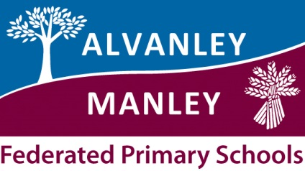

School Uniform Policy
At Alvanley & Manley Primary Schools we recognise that school uniform plays a valuable role in contributing to the ethos of the school.
Having an identifiable uniform enables all children to feel that they belong to our school family and that they are proud to attend our schools.
It helps all children to feel welcome at the school, encouraging both a positive identity and good behaviour.
Our uniform reflects the high standard we strive for and above all, we believe that school uniform supports effective teaching and learning.
We expect children to dress smartly and attend school in the correct uniform. The expectation is that children must wear items with our school logo on or the same colour / design.

Alvanley Uniform
School uniform is a royal blue sweatshirt or cardigan which should be embroidered with the school logo, a pale blue polo shirt with grey/ black skirts, trousers or shorts – Jeans are not acceptable.
In summer blue gingham or similar summer dresses can be worn.
Sensible / appropriate black shoes, trainers are not appropriate and should not be worn.
Blue and white PE kits printed with the school logo should be worn by all children for PE.
Reception children can wear black shorts and an embroidered white embroidered cotton T-shirt if the standard PE kits are too large.
Please also provide your child with a pair of plimsolls / trainers (elastic sided for Infant children) or similar. School PE kits are to be left in school during the week.

Manley Uniform
School uniform is a burgundy sweatshirt or cardigan which should be embroidered with the school logo, a pale blue polo shirt with grey/ black skirts, trousers or shorts – Jeans are not acceptable.
In summer blue gingham or similar summer dresses can be worn.
Sensible / appropriate black shoes, trainers are not appropriate and should not be worn.
Burgundy and white PE kits printed with the school logo should be worn by all children for PE.
Reception children can wear black shorts and an embroidered white cotton T-shirt if the standard PE kits are too large.
Please also provide your child with a pair of plimsolls / trainers (elastic sided for Infant children) or similar. School PE kits are to be left in school during the week.

All children:
All long hair must be tied back and hair accessories must be discreet.
Hairstyles should be appropriate for school at all times, please note that we do not allow extreme hair styles such as dyed hair or hair cut with lines or patterns.
No jewellery, except small stud earrings which must be removed for PE. A small watch can be worn but please consider its value in the event of damage or if it gets lost.
No make-up or nail varnish can be worn.

Uniform suppliers are:
Touchline
Orders can be placed online, telephone or email with the order form.
If parents choose the free delivery to school option this may take up to 4 weeks. (They collate orders and then deliver them together). They will also deliver in bulk any orders for September or new terms. If parents choose carriage to their home address this will be £3.95 for orders under £50 and FOC for any orders over £50.
http://www.touchline-embroidery.net/alvanley-primary/

http://www.touchline-embroidery.net/manley-village

Tesco
This can be ordered on-line. When ordering with Tesco, school receives 5% cashback from them which could be really beneficial to us. The website to use is:
https://www.tesco.com/direct/ues/?icid=schooluniform_lhn_UniformEmbroideryService

https://www.tesco.com/direct/ues/?icid=schooluniform_lhn_UniformEmbroideryService

