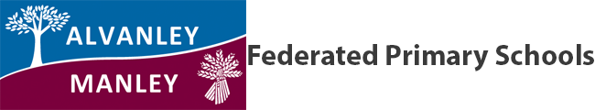
Pupil Premium Statement – Alvanley Primary School

Background

The pupil premium is a Government initiative that targets extra funds at pupils from deprived backgrounds. Research shows that children from deprived backgrounds generally underachieve compared to their non-deprived peers and the premium is provided in order to support these pupils in reaching their potential.

The Government have used pupils entitled to free school meals as an indicator of deprivation and have deployed a fixed amount of money to schools, per pupil, based on the number of pupils registered for those meals. The pupil premium allocation for the year 2016-2017 is £1,320 per pupil.

At Alvanley Primary School, our intention is to provide additional opportunities for disadvantaged children to narrow the academic gap to their peers. In addition, there may also be non-curricular enrichment opportunities designed to build the social confidence of eligible pupils.

Principles

• We meet the needs of all pupils through teaching and learning opportunities.

• We assess and address the needs of socially disadvantaged children and make additional provisions in the areas of greatest need.

• In making provision for socially disadvantaged pupils, we recognise that not all pupils who receive free school meals will be socially disadvantaged. We also recognise that some children who are socially disadvantaged have not been recognised by ‘free meal provision’. We therefore reserve the right to allocate additional provision to the children most in need.

Current Provision

- Providing high quality teaching, in all classes, with a differentiated curriculum appropriate for all children in the classroom.
- Providing additional interventions with a teacher, or experienced teaching assistant, focussed on overcoming gaps in learning.

Reporting

- It will be the responsibility of the Headteacher, SENCO and Pupil Premium leader to include the following information in the annual data report for the Governors:

- An outline of the provision that was made since the last annual report.
- An evaluation of the academic progress of disadvantaged pupils when compared to other groups.
- An evaluation of the cost effectiveness of additional academic and social provision to ensure the efficiency of additional funding expenditure.

Success Criteria

The success criteria for the Pupil Premium Policy are:

- Early assessment for socially disadvantaged children.
- Early provision of required additional support for disadvantaged children.
- An effective system for identifying, assessing and monitoring pupils.
- Providing a consistent approach throughout the federation.
- Creating a learning environment where all pupils, regardless of social circumstance, should make equal progress.

Geoff Old
Pupil Premium Coordinator
13th June 2017
Review date – September 2017

